**Experiment 8**

**Date of Performance :**  **Date of Submission:**

**SAP Id: 60004190057** **Name : Junaid Altaf Girkar**

**Div:** **A** **Batch : A4**

**Aim of Experiment**

Study of packet sniffer tools : wireshark, :

a. Download and install wireshark and capture icmp, tcp, and http packets in promiscuous mode.

b. Explore how the packets can be traced based on different filters. (CO5)

**Theory:**

Wireshark is a free and open-source packet analyzer. It is used for network troubleshooting, analysis, software and communications protocol development, and education. Wireshark lets the user put network interface controllers into promiscuous mode (if supported by the network interface controller), so they can see all the traffic visible on that interface including unicast traffic not sent to that network interface controller's MAC address. However, when capturing with a packet analyzer in promiscuous mode on a port on a network switch, not all traffic through the switch is necessarily sent to the port where the capture is done, so capturing in promiscuous mode is not necessarily sufficient to see all network traffic. Port mirroring or various network taps extend capture to any point on the network. Simple passive taps are extremely resistant to tampering.

**Capturing ICMP Packets:**

| C:\Users\junai>ping 8.8.8.8  Pinging 8.8.8.8 with 32 bytes of data: Reply from 8.8.8.8: bytes=32 time=5ms TTL=119 Reply from 8.8.8.8: bytes=32 time=6ms TTL=119 Reply from 8.8.8.8: bytes=32 time=2ms TTL=119 Reply from 8.8.8.8: bytes=32 time=3ms TTL=119  Ping statistics for 8.8.8.8:  Packets: Sent = 4, Received = 4, Lost = 0 (0% loss), Approximate round trip times in milli-seconds:  Minimum = 2ms, Maximum = 6ms, Average = 4ms |
| --- |

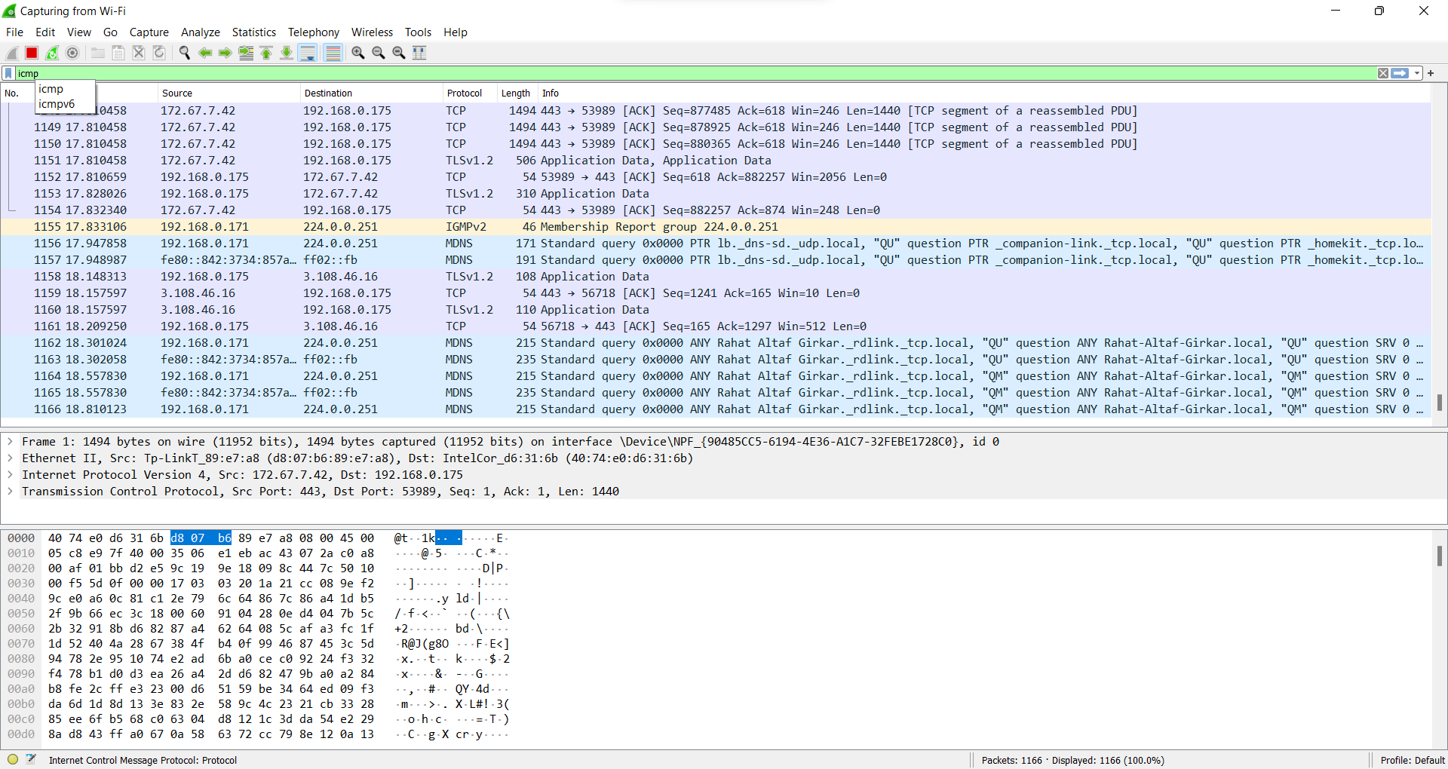

**Capturing TCP Packets:**

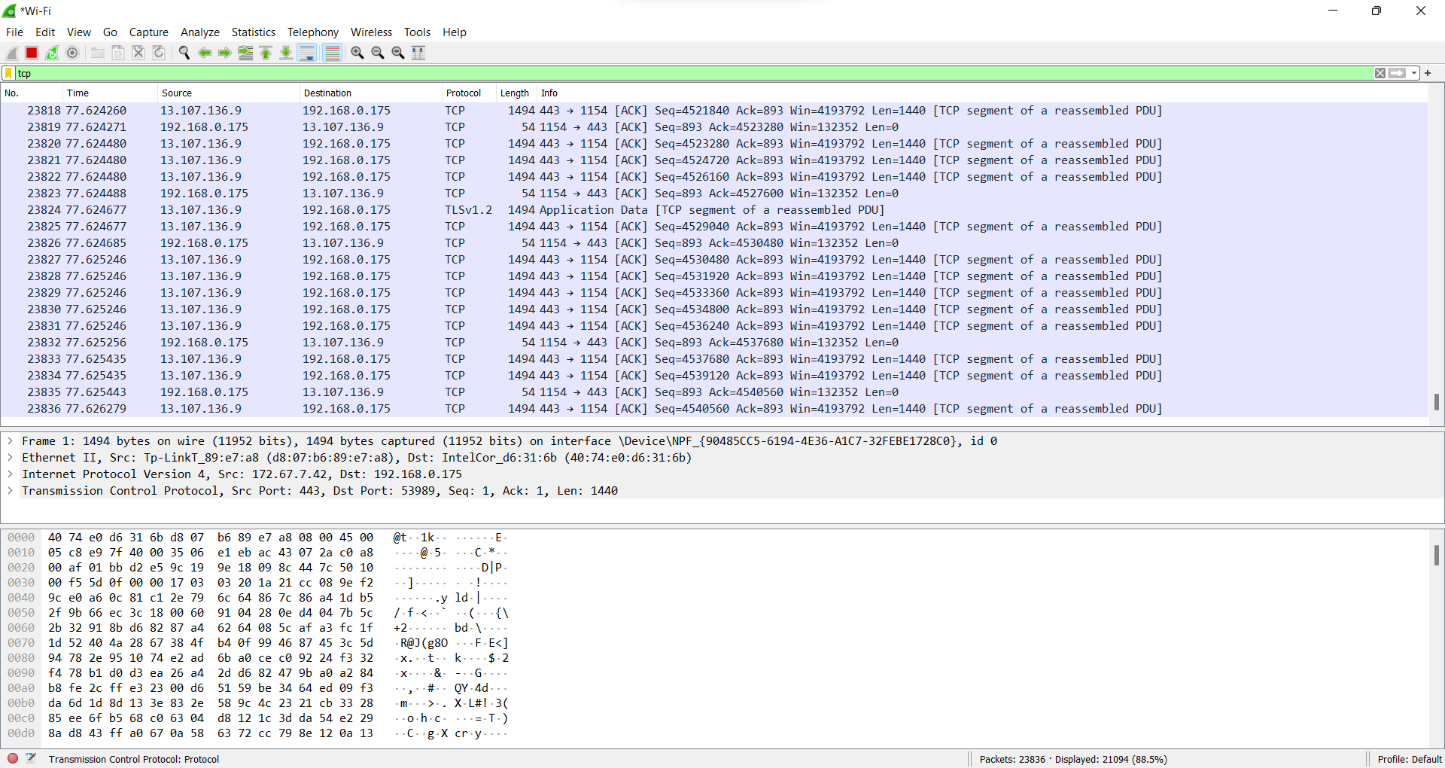

**Capturing FTP Packets:**

| C:\Users\junai>ftp ftp.cdc.gov Connected to ftp.cdc.gov. 220 Microsoft FTP Service 200 OPTS UTF8 command successful - UTF8 encoding now ON. User (ftp.cdc.gov:(none)): anonymous 331 Anonymous access allowed, send identity (e-mail name) as password. Password: 230 User logged in. ftp> ls 200 PORT command successful. 150 Opening ASCII mode data connection. .change.dir .message pub Readme Siteinfo w3c welcome.msg 226 Transfer complete. ftp: 67 bytes received in 0.03Seconds 2.03Kbytes/sec. |
| --- |

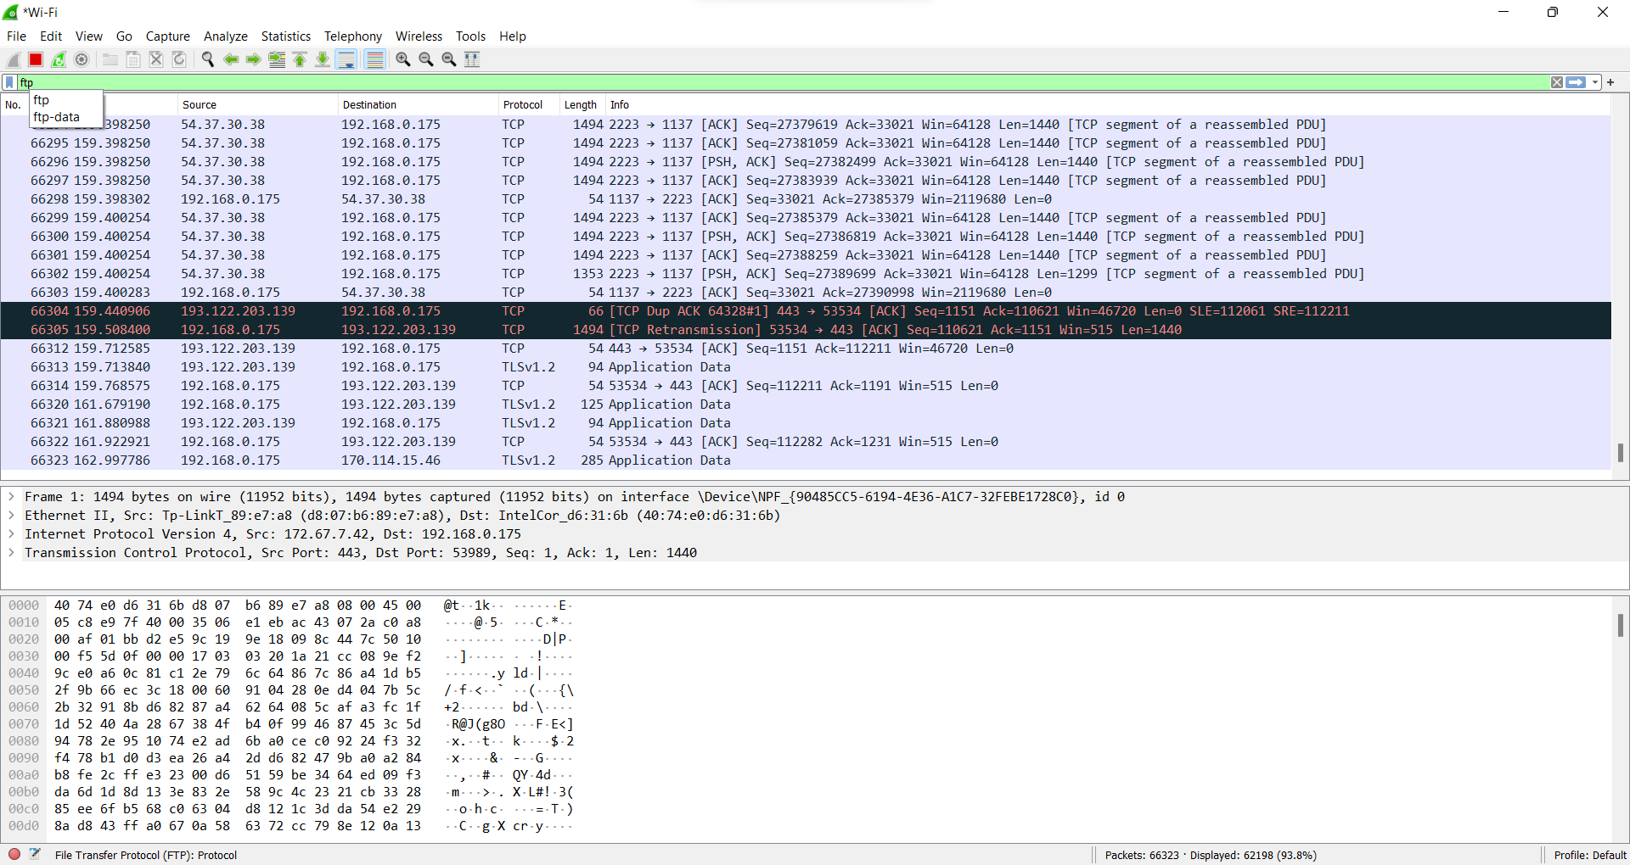

**Capturing ARP Packets:**

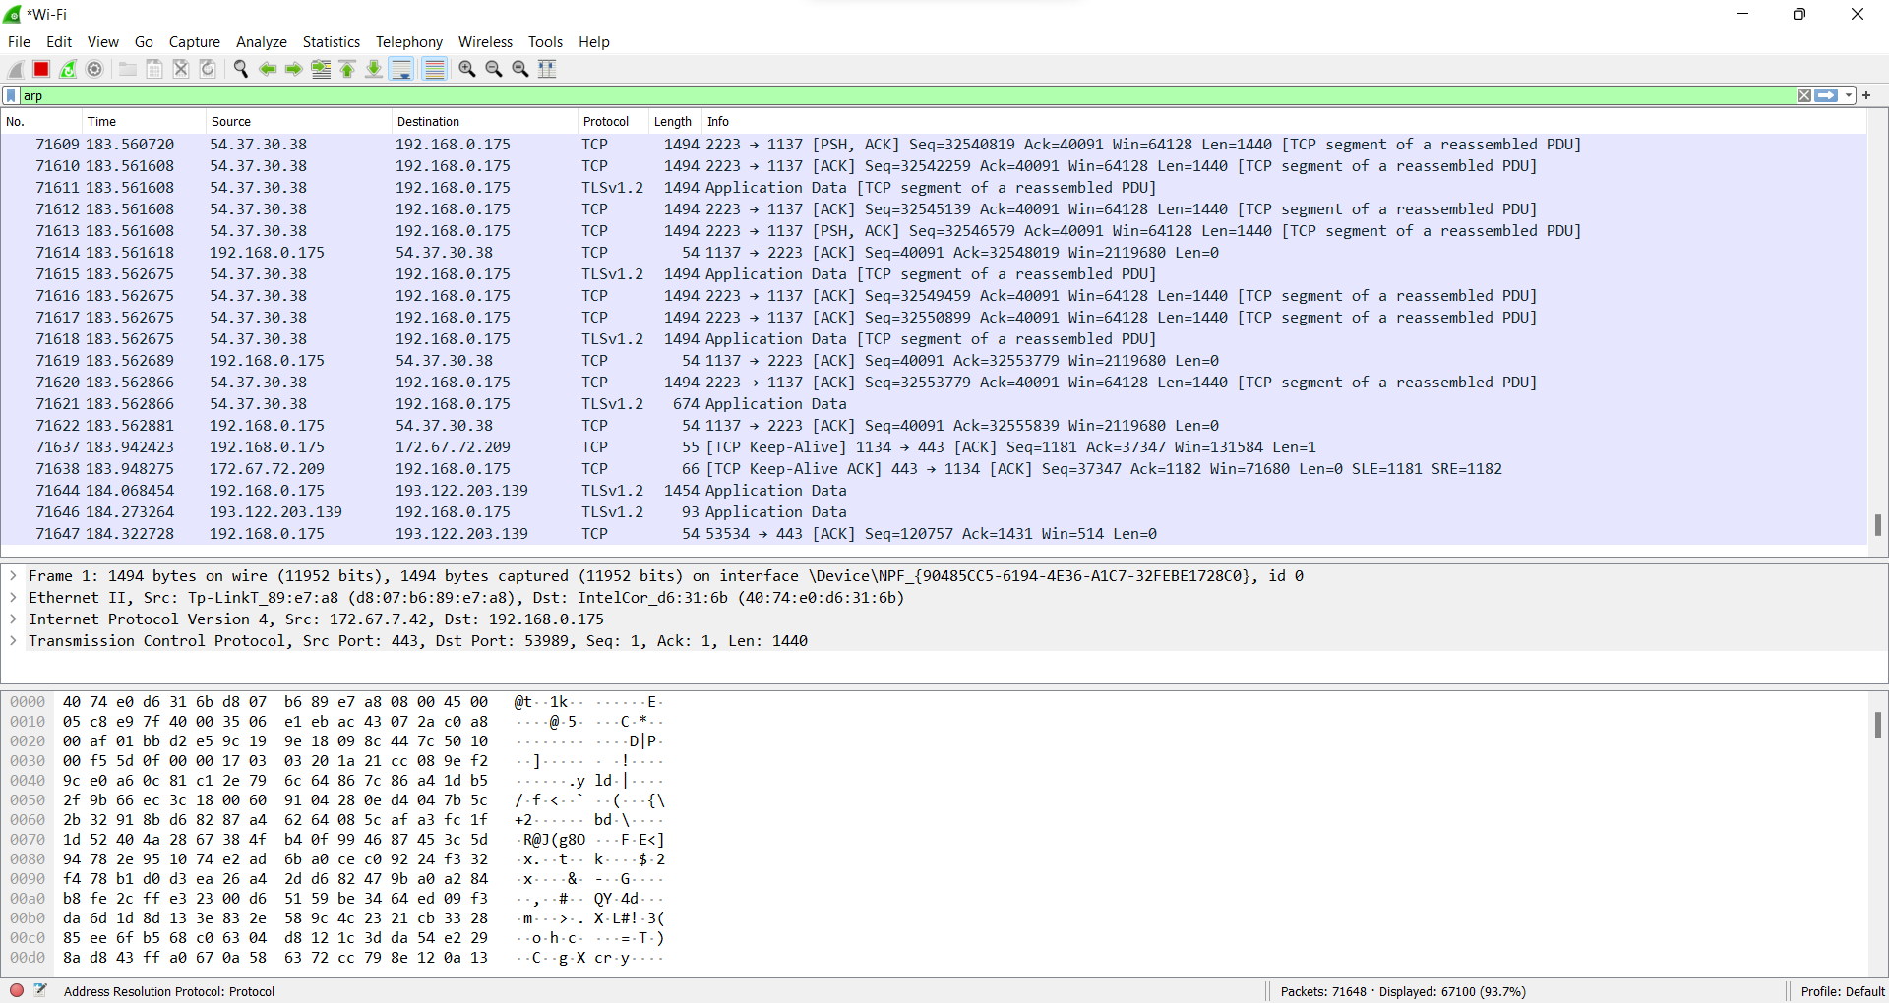

**B] Tracing Packets based on filters:**

**1] Filter Results by Port:**

**Traces all packets related to Port 80.**

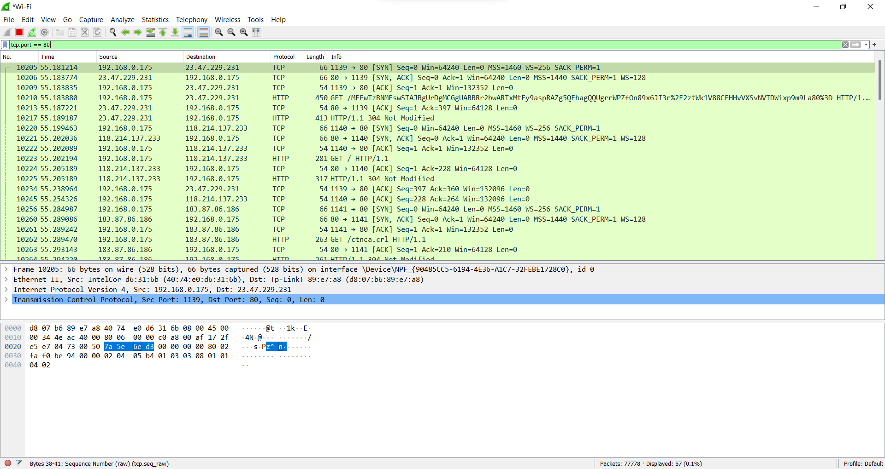

**2] Filter by Delta Time :**

**Displays tcp packets with delta time of greater than 0.500 sec**

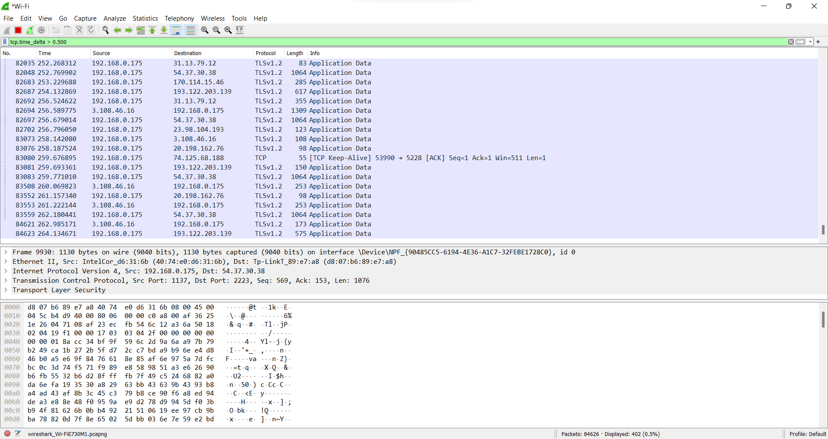

**3] Filter by Byte Sequence:**

**Displays packets which contain a particular byte sequence.**

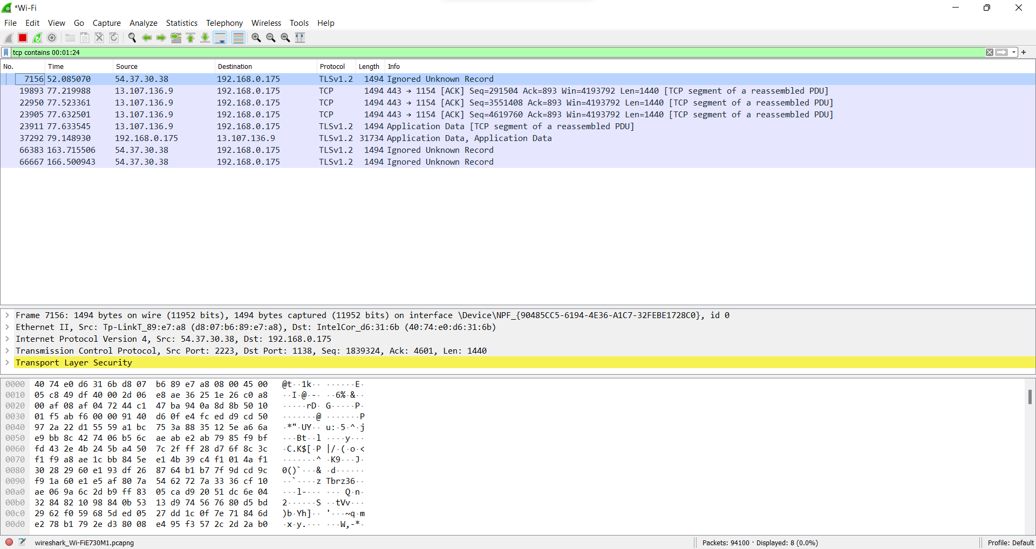

**4] Filter by Source IP Address:**

**Displays packets which have source IP address same as the one provided in the argument.**

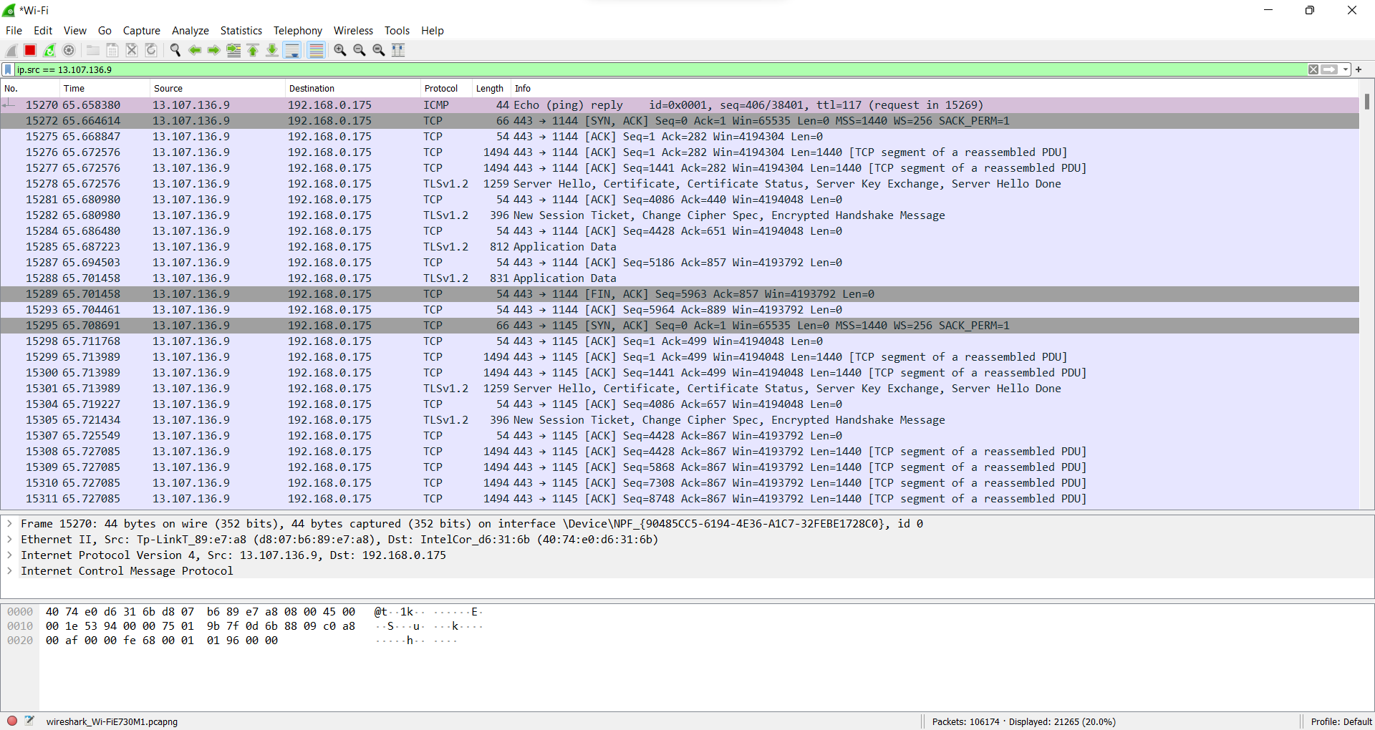

**CONCLUSION**

Thus, we have successfully studied packet sniffing tools (wireshark) and explored how packets can be traced on the basis of different filters.